|  |  |  |  |  |
| --- | --- | --- | --- | --- |
| Asset | **Central East Asset – Gbaran/Bonny Asset Subsurface (FMT)** | | **Field** | Gbaran and Koroama fields |
| **Meeting** | Well Integrity Risk Assessment Review for GBAR011, GBAR025, KOMA006, KOMA007, KOMA008 & KOMA009 | | | |
| **Date** | 07/01/2021 | | | |
| **Attendees** | |  | | |
| * Benjamin Ajaraogu –*PT/WI TA2, SPDC WRFM* * Diepere Taiger –*WI Advisor, SPDC WRFM* * Femi Obakhena –*PT/WI Focal Point* * David Ogbonna –*PT (Reporting)* * Conrad Ibekwe –*–CWI, Well Intervention Ops* | | * Igbereyivwe Steve *–CWI, Well Intervention Ops* * Igbigioyibo Memberr *–Ops Field Team Leader, Gbaran PU* * Chinedu Onyeme *–Ops Field Team Leader, Gbaran PU* * Haruna Akinlolu *–Ops Field Supervisor, Gbaran PU* | | |
| **Objectives** | The objective of the Risk Assessment review was:   1. To generate Risk Assessment Matrices for GBAR011, 25, KOMA006, 7, 8 & 9 for which Ops_WIT cannot be carried out due to liquid-loading tendencies with the wells. 2. To agree on forward plan(s) to mitigate the associated risks and carry out the required Ops_WIT. 3. To seek deviation for wells with overdue (or nearly overdue) Ops_WIT. | | | |
| **Key Highlights (Summary of Decisions)** | **Category 1:** Wells without SCE failures (GBAR011, GBAR025, KOMA007 & KOMA008)   1. All 4 wells are currently Action Code 0 in eWIMS. 2. All 4 wells have no history of reported SCE failures, with all Christmas tree and wellhead valves tested okay for over 4 years period. 3. KOMA008 is red on overdue Ops_WIT, while the other 3 wells will be overdue for Ops_WIT latest by 10th Feb 2021. 4. Risk assessed each well as low risk. *See RAM rating in table below.* 5. Ops_WIT deviation of a maximum of 9 months (from overdue date) approved for each well.   **Category 2:** Wells with SCE failures (KOMA006 & KOMA009)   1. Both wells are currently Action Code 9 (red) in eWIMS. 2. Multiple SCE failures were reported during the latest PM activity on both wells. 3. KOMA006 (Cmb_WITSIT) & KOMA009 (Ops_WIT) will be overdue by 9th Jun & 16th Jan 2021, respectively. 4. Ops_WIT deviation not approved, pending close-out of assigned actions. 5. Risk Assessment to be re-scheduled. | | | |

**Summary of Well Integrity Issues:**

**Category 1:** Wells without SCE failures

|  |  |  |  |  |  |
| --- | --- | --- | --- | --- | --- |
| Well | Action  Code | Goes Red Reason | Goes Red On | Well History/Analysis | Risk Assessment Outcome/ Mitigations / Actions |
| GBAR011 | **0** | Ops_WIT due | 10-Feb-21 | * Gas producer completed as SSS on D6000C. * Currently producing at 7 MMscf/d with FTHP of 1236 psig. * No failures reported during last Cmb_WITSIT in Jul 2020. * Unable to carry-out Ops_WIT due to liquid loading tendencies. | * Risk Assessed as: **P-2B; A-1B; C-2B; E-2B** * Increased well surveillance and monitor well parameters. *–Memberr (Weekly)* * Enter Ops_WIT deviation for 9 months max in FSR. *–Femi (15-Jan-21)* * Carry-out Ops_WIT at next available window. *–Memberr (10-Nov-21)* * Prepare N2 lift proposal, as contingency. *–David* |
| GBAR025 | **0** | Ops_WIT due | 27-Jan-21 | * Gas producer completed as SSS on E3000B. * Currently producing at 43 MMscf/d with FTHP of 1683 psig. * No failures reported during last Cmb_WITSIT in Jul 2020. * Unable to carry-out Ops_WIT due to liquid loading tendencies. | * Risk Assessed as: **P-2B; A-1B; C-2B; E-2B** * Increased well surveillance and monitor well parameters. *–Memberr (Weekly)* * Enter Ops_WIT deviation for 9 months max in FSR. *–Femi (15-Jan-21)* * Carry-out Ops_WIT at next available window. *–Memberr (27-Oct-21)* * Prepare N2 lift proposal, as contingency. *–David* |
| KOMA007 | **0** | Ops_WIT due | 21-Jan-21 | * Gas producer completed as SSS on D7000X. * Currently producing at 18 MMscf/d with FTHP of 1862 psig. * No failures reported during last Cmb_WITSIT in Jul 2020. * Unable to carry-out Ops_WIT due to liquid loading tendencies. | * Risk Assessed as: **P-2B; A-1B; C-2B; E-2B** * Increased well surveillance and monitor well parameters. *–Memberr (Weekly)* * Enter Ops_WIT deviation for 9 months max in FSR. *–Femi (15-Jan-21)* * Carry-out Ops_WIT at next available window. *–Memberr (21-Oct-21)* * Prepare N2 lift proposal, as contingency. *–Femi* |
| KOMA008 | **0** | Ops_WIT freq. | 18-Nov-20 | * Gas producer completed as SSD on E9000X & F1000X. * Currently producing at 55 MMscf/d with FTHP of 1403 psig. * No failures reported during last Cmb_WITSIT in Jun 2020. * Ops_WIT overdue. Unable to carry-out Ops_WIT due to liquid loading tendencies. | * Risk Assessed as: **P-2B; A-1B; C-2B; E-2B** * Increased well surveillance and monitor well parameters. *–Memberr (Weekly)* * Enter Ops_WIT deviation for 7 months max in FSR. *–Femi (15-Jan-21)* * Carry-out Ops_WIT at next available window. *–Memberr (18-Aug-21)* * Prepare N2 lift proposal, as contingency. *–Femi* |

**Category 2:** Wells with SCE failures

|  |  |  |  |  |  |
| --- | --- | --- | --- | --- | --- |
| Well | Action  Code | Goes Red Reason | Goes Red On | Well History/Analysis | Risk Assessment Outcome/ Mitigations / Actions |
| KOMA006 | **9** | SSSV, SV | 23-Nov-20 | * Gas producer completed as SSS on E1000X. * Currently producing at 37 MMscf/d with FTHP of 1622 psig. * SSSV & SV failures reported during last Ops_WIT in Nov 2020. * Well has liquid loading tendencies, requiring rocking or N2 lift to re-open after any shut-in. | * Increase well surveillance and monitor well parameters. *–Memberr (Weekly)* * Carry-out valve greasing on Swab Valve. *–Memberr (11-Jan-21)* * Cycle SSSV. *–Embedded CWI Crew / Memberr (11-Jan-21)* * Re-schedule Risk Assessment, pending outcome of valve greasing. *–David (14-Jan-21)* * Prepare N2 lift proposal, as contingency. *–Femi* |
| KOMA009 | **9** | UMV, LMV | 21-Mar-18 | * Gas producer completed smart on C9400X, D1000X & D6000X. * Currently producing at 73 MMscf/d with FTHP of 1373 psig. * UMV & LMV failures reported during last Cmb_WITSIT in Jun 2020. * Well has liquid loading tendencies, requiring rocking or N2 lift to re-open after any shut-in. | * Increase well surveillance and monitor well parameters. *–Memberr (Weekly)* * Re-schedule Risk Assessment *–David (14-Jan-21)* * Repair/Replace faulty Christmas tree valves. *–Conrad (31-Mar-21)* * Prepare N2 lift proposal, as contingency. *–Femi* |

**Overall Risk Assessment Outcome:**

Risk(s) that may arise due to the observed issue(s)?

1. Inability to identify well barrier or SCE failure
2. Failed well barrier (gas under pressure), potentially leading to the following Top-Event:
   1. Loss of hydrocarbon containment, gas explosion and/or fire.
   2. Environmental pollution from the hydrocarbon.
   3. Impact on Company asset & reputation.

|  |  |  |  |  |  |
| --- | --- | --- | --- | --- | --- |
| **Well** | **RAM Rating** | | | | **Overall Rating** |
| **People** | **Asset** | **Environment** | **Community** |
| GBAR011 | 2B | 1B | 2B | 2B | Low Risk |
| GBAR025 | 2B | 1B | 2B | 2B | Low Risk |
| KOMA007 | 2B | 1B | 2B | 2B | Low Risk |
| KOMA008 | 2B | 1B | 2B | 2B | Low Risk |

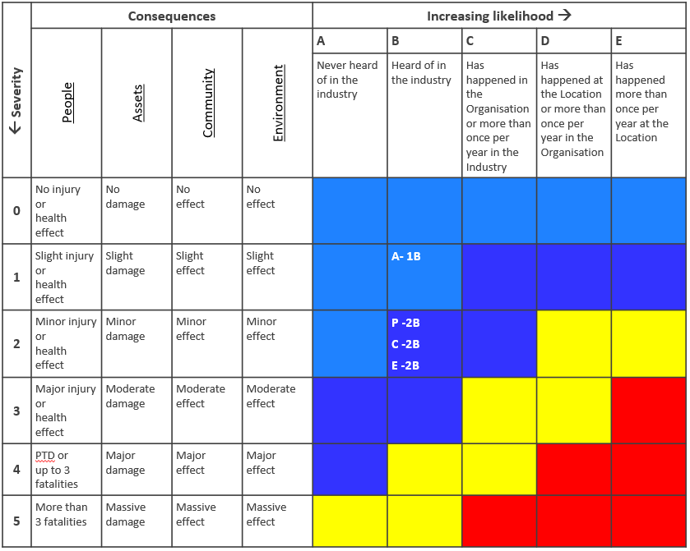

**Existing Mitigations:**

1. All wells are secured within a fenced location. Hence, access is restricted to 3rd parties.
2. There are Station Attendants at each remote location, 24/7.
3. Remote monitoring systems are in place to monitor well pressures realtime.
4. Fire & Gas alarm systems are available at each well location.